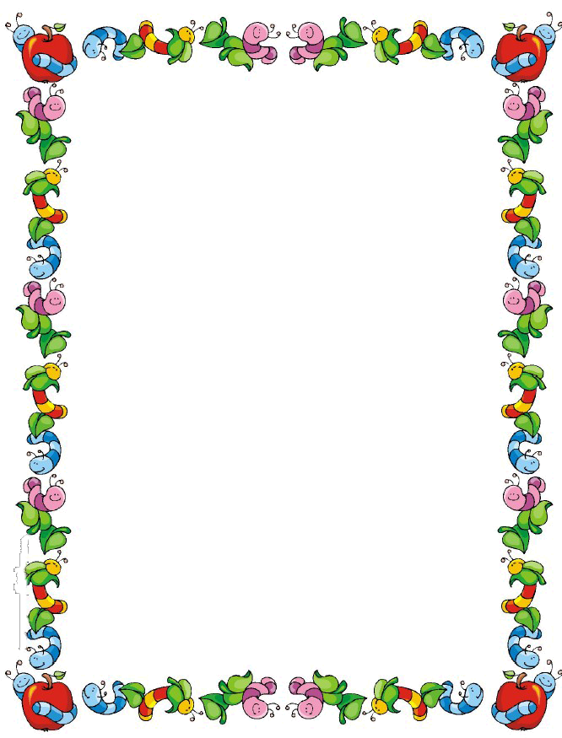

**First Grade Supply List**

* Sentence strips
* Dot markers
* Washable markers (Crayola)
* Dry erase markers
* Tape
* Play-Doh pack of 4 to 6 cans
* Ziplock sandwich bags
* Liquid glue & glue sticks
* 1 pack Printer paper
* Construction paper
* Lined writing paper
* 2 Disinfecting wipes
* 2 Boxes of Tissues
* Duo tang folder
* Manilla folder
* 2 Hand Sanitizer (12oz or larger)
* Watercolor paint
* Ink Pads
* 1 pair of kid friendly scissors
* 1 pack of No. 2 pencils
* 1 plastic pencil box